
- Code: N352-1L012FLAM
Upper : Leather Lining : Leather Sole : PU (Polyurethane) Accessories : Buckle Heel Type : ANATOMIC

RUBIK - L012Beige

Upper - Leather
Lining -Leather
Midsole - PU(polyurethane)
Sole - PU(polyurethane)
Accessories - Buckle
Heel Type - Flat Anatomic

Upper - Leather
Lining -Leather
Midsole - PU(polyurethane)
Sole - PU(polyurethane)
Accessories - Buckle
Heel Type - Flat Anatomic

Upper - Leather
Lining -Leather
Midsole - PU(polyurethane)
Sole - PU(polyurethane)
Accessories - Buckle
Heel Type - Flat Anatomic
Upper : Leather Lining : Leather Sole : PU (Polyurethane) Accessories : Buckle Heel Type : ANATOMIC
RUBIK- ORCHIDE
- Code: N352-1L012ORCH
Upper : Leather Lining : Leather Sole : PU (Polyurethane) Accessories : Buckle Heel Type : ANATOMIC
RUBIK-YELLOW

Upper - Leather
Lining -Leather
Midsole - PU(polyurethane)
Sole - PU(polyurethane)
Accessories - Buckle
Heel Type - Flat Anatomic

Upper - Leather
Lining -Leather
Midsole - PU(polyurethane)
Sole - PU(polyurethane)
Accessories - Buckle
Heel Type - Flat Anatomic
Upper : Leather Lining : Leather Sole : PU (Polyurethane) Accessories : Buckle Heel Type : ANATOMIC

Upper - Leather
Lining -Leather
Midsole - PU(polyurethane)
Sole - PU(polyurethane)
Accessories - Buckle
Heel Type - Flat Anatomic
RUBIK- BLUE
- Code: N352-1L012BLUE
Upper : Leather Lining : Leather Sole : PU (Polyurethane) Accessories : Buckle Heel Type : ANATOMIC
RUBIK-GREEN
RUBIK-DARK RED
RUBIK - L012Pastel Pink

Upper - Leather
Lining -Leather
Midsole - PU(polyurethane)
Sole - PU(polyurethane)
Accessories - Buckle
Heel Type - Flat Anatomic
Upper : Leather Lining : Leather Sole : PU (Polyurethane) Accessories : Buckle Heel Type : ANATOMIC
RUBIK - L012Purple

Upper - Leather
Lining -Leather
Midsole - PU(polyurethane)
Sole - PU(polyurethane)
Accessories - Buckle
Heel Type - Flat Anatomic
Upper : Leather Lining : Leather Sole : PU (Polyurethane) Accessories : Buckle Heel Type : ANATOMIC

Upper - Leather
Lining -Leather
Midsole - PU(polyurethane)
Sole - PU(polyurethane)
Accessories - Buckle
Heel Type - Flat Anatomic
RUBIK-TURQOISE
ZOE-FLAME
RUBIK - L012Turqoise

Upper - Leather
Lining -Leather
Midsole - PU(polyurethane)
Sole - PU(polyurethane)
Accessories - Buckle
Heel Type - Flat Anatomic
RUBIK - L012White

Upper - Leather
Lining -Leather
Midsole - PU(polyurethane)
Sole - PU(polyurethane)
Accessories - Buckle
Heel Type - Flat Anatomic
ZOE - 1L011

ZOE-BLUE

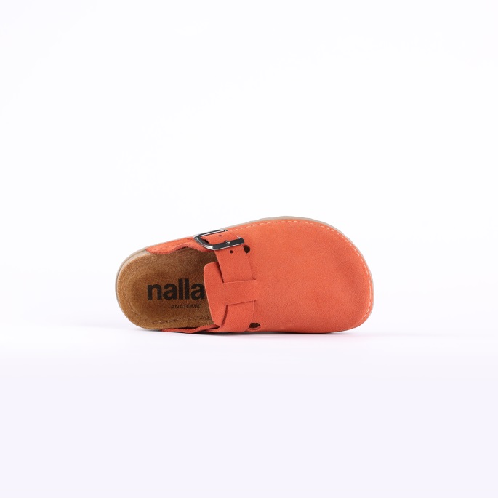
- Code: N352-1L012MOCA
Upper : Leather Lining : Leather Sole : PU (Polyurethane) Accessories : Buckle Heel Type : ANATOMIC

RUBIK-Mocha

- Code: N402-2L005WHIT
Upper : Leather Lining : Leather Sole : PU (Polyurethane) Accessories : Buckle Heel Type : ANATOMIC

NOMAD-White
SLIPPERS – NEXA-

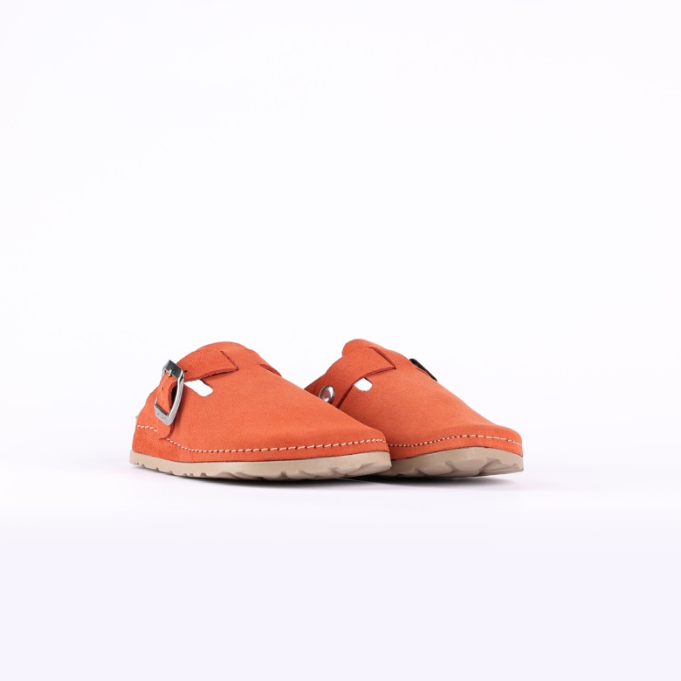

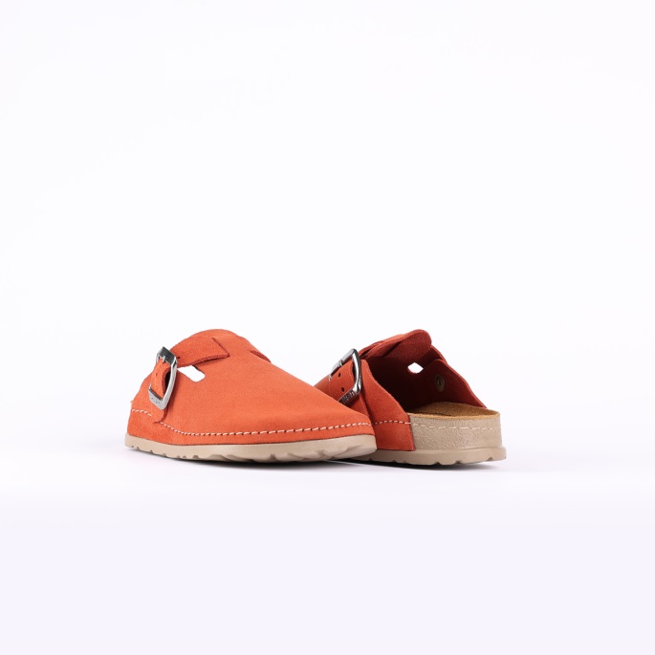

Code: N255-1V081
Upper : Velour
Lining : Leather Sole : PU (Polyurethane) Accessories : Yes Heel Type : Anatomic

SIZE: 25-35

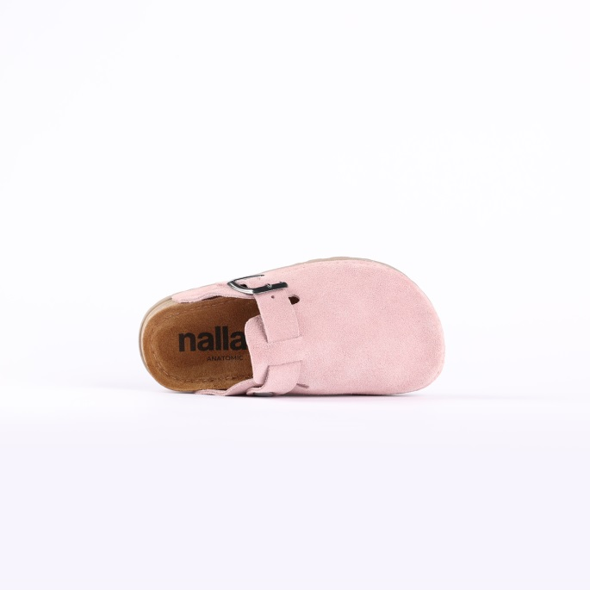
SLIPPERS – NEXA- PINK

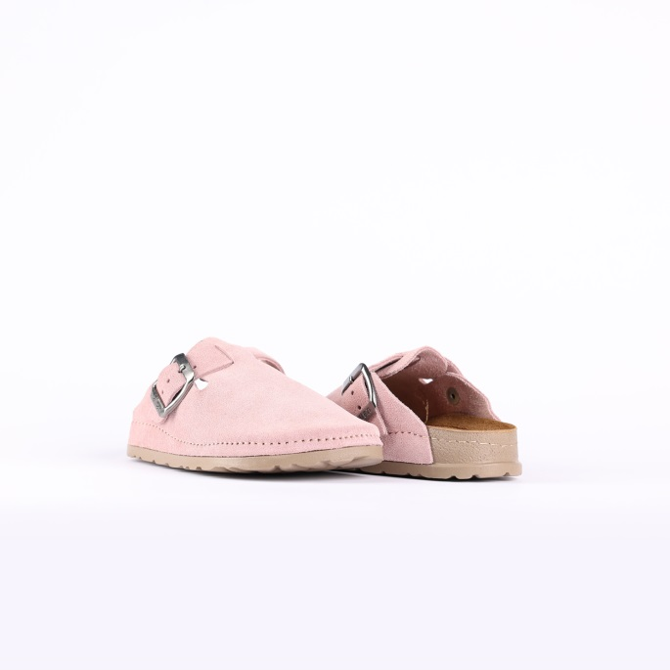
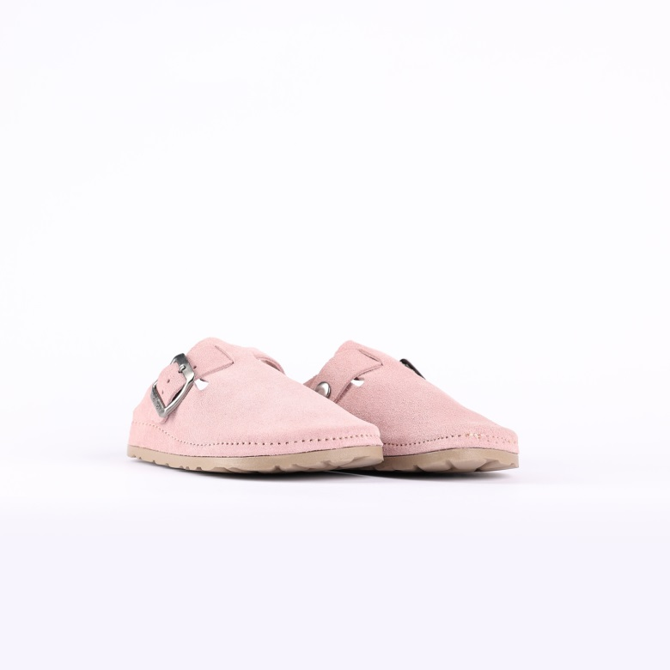

Code: N255-1V081PINK
Upper : Velour
Lining : Leather Sole : PU (Polyurethane) Accessories : Yes Heel Type : Anatomic

- Code:

SIZE: 25-35

SLIPPERS – NEXA- LIGHT GRAY

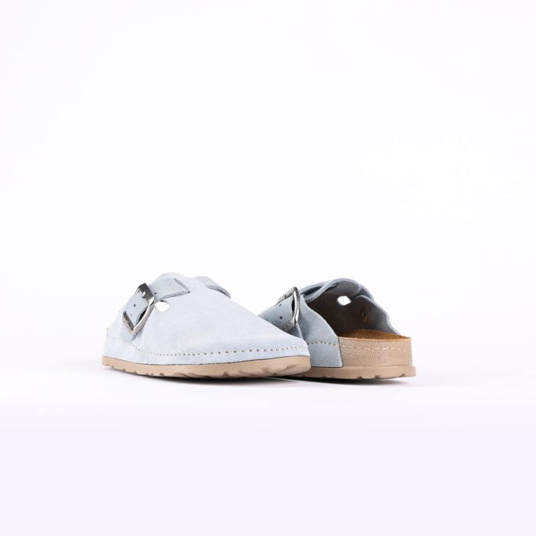
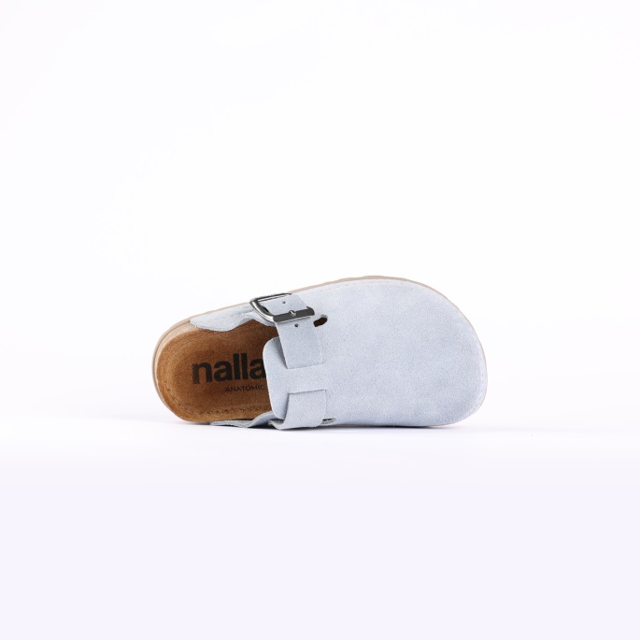
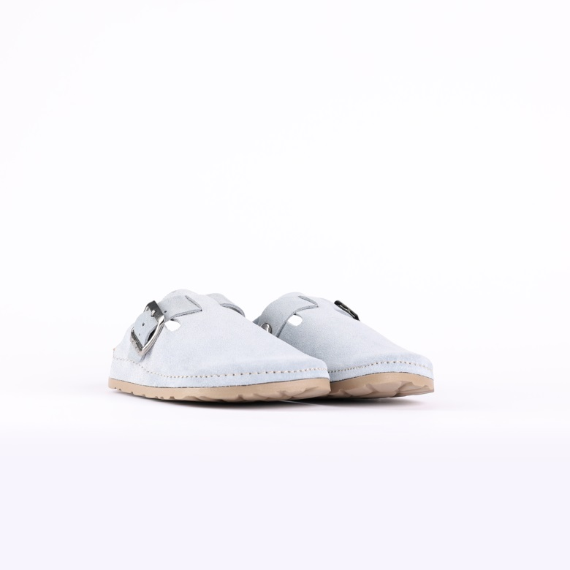

Code: N255-1V081LGRY
Upper : Velour
Lining : Leather Sole : PU (Polyurethane) Accessories : Yes Heel Type : Anatomic

- Code:

SIZE: 25-35

SLIPPERS – NEXA- BLAND

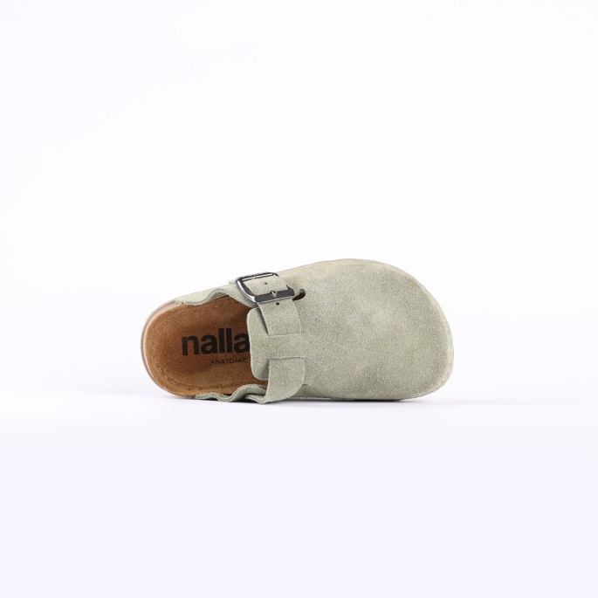
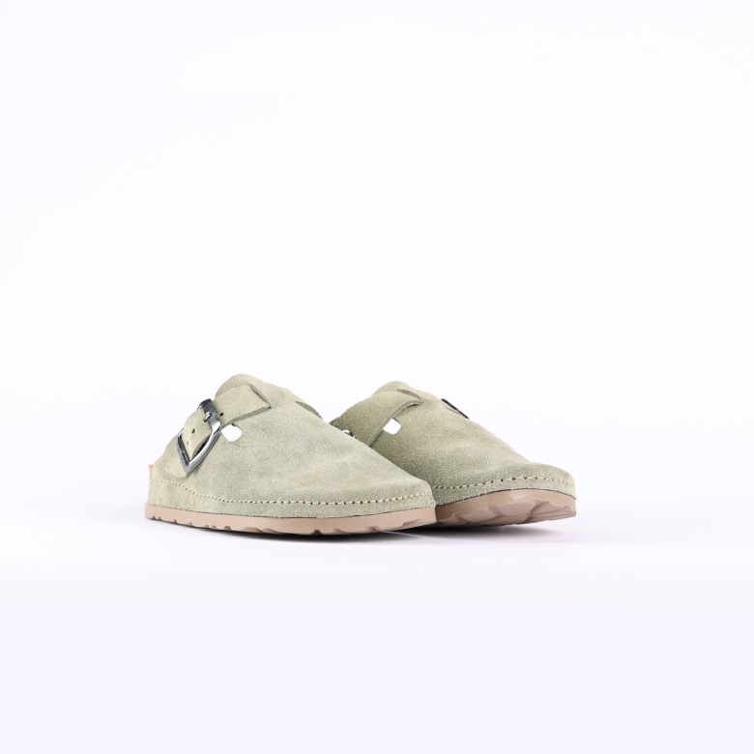

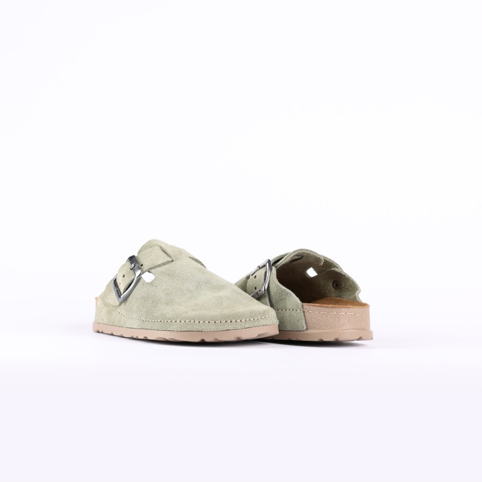

Code: N255-1V081BLAN
Upper : Velour
Lining : Leather Sole : PU (Polyurethane) Accessories : Yes Heel Type : Anatomic

- Code:

SIZE: 25-35

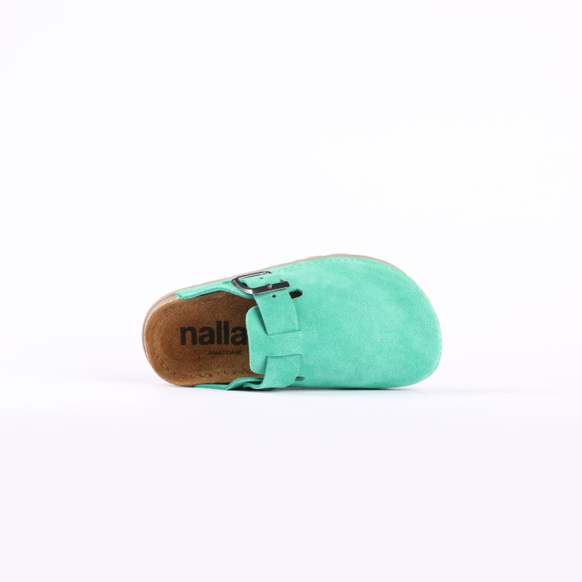
SLIPPERS – NEXA- CLEAN GREEN

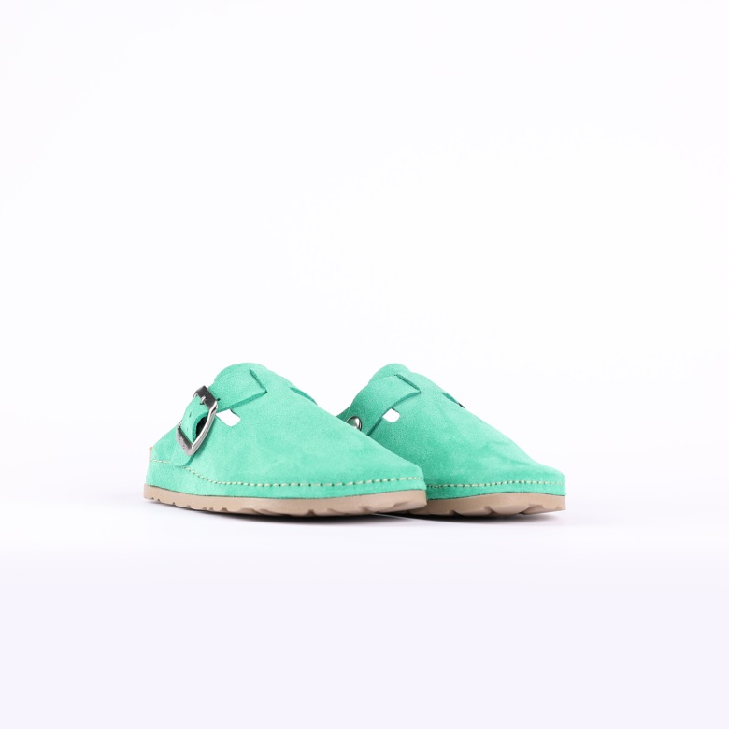

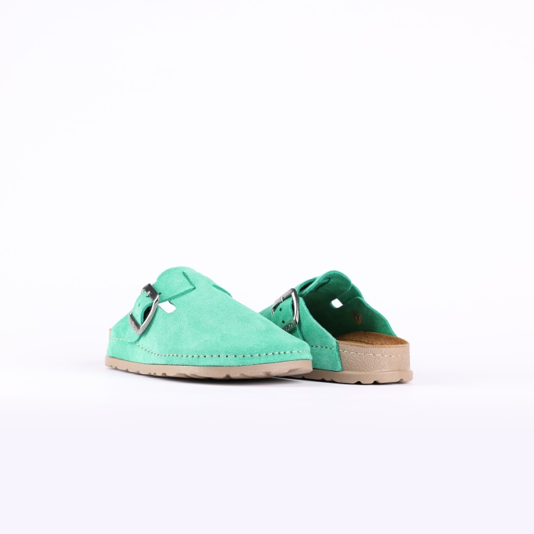

Code: N255-1V081CGRE
Upper : Velour
Lining : Leather Sole : PU (Polyurethane) Accessories : Yes Heel Type : Anatomic

SIZE: 25-35

SLIPPERS – NEXA-

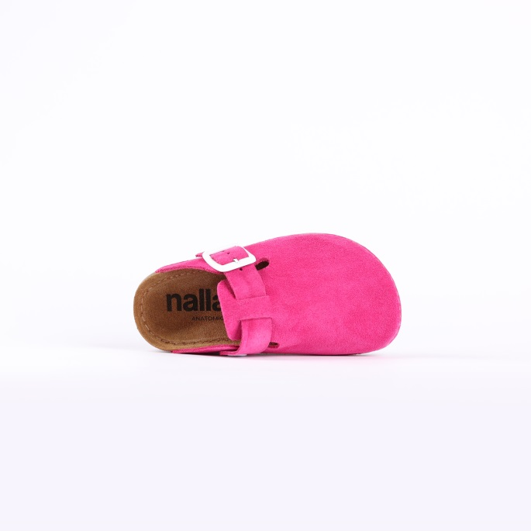
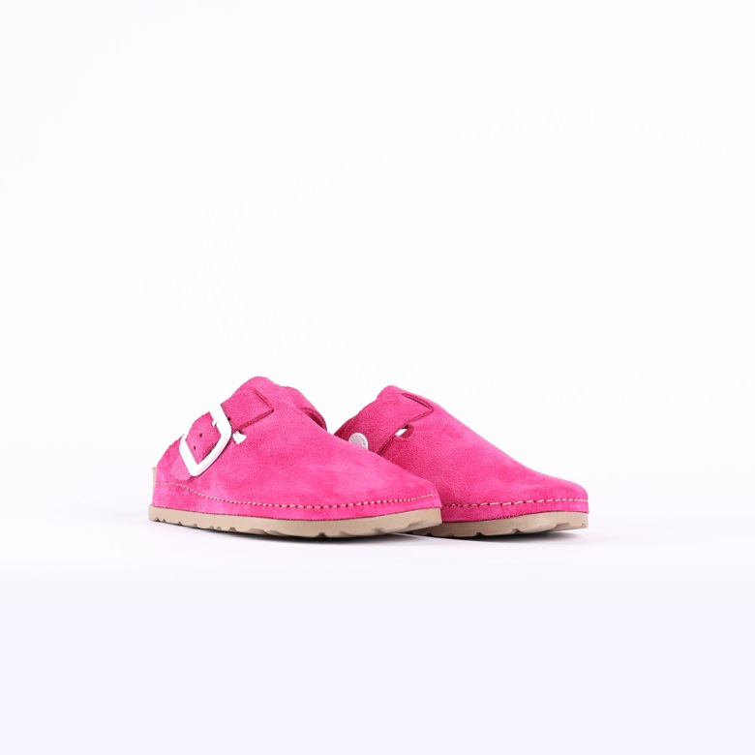
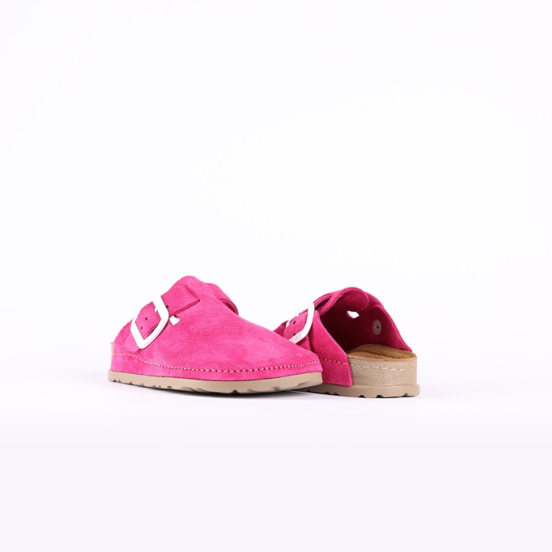

Code: N255-1V081
Upper : Velour
Lining : Leather Sole : PU (Polyurethane) Accessories : Yes Heel Type : Anatomic

SIZE: 25-35

SLIPPERS – NEXA- RED

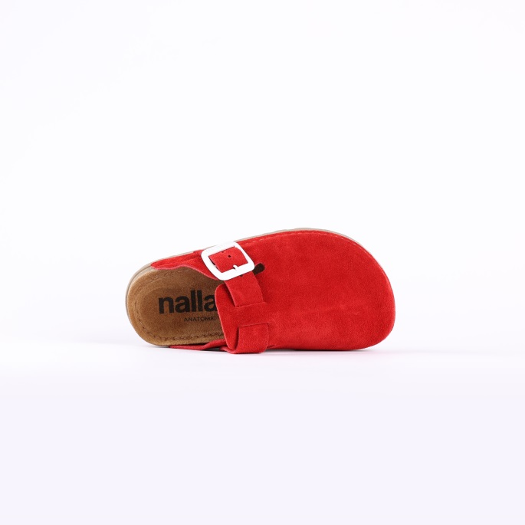
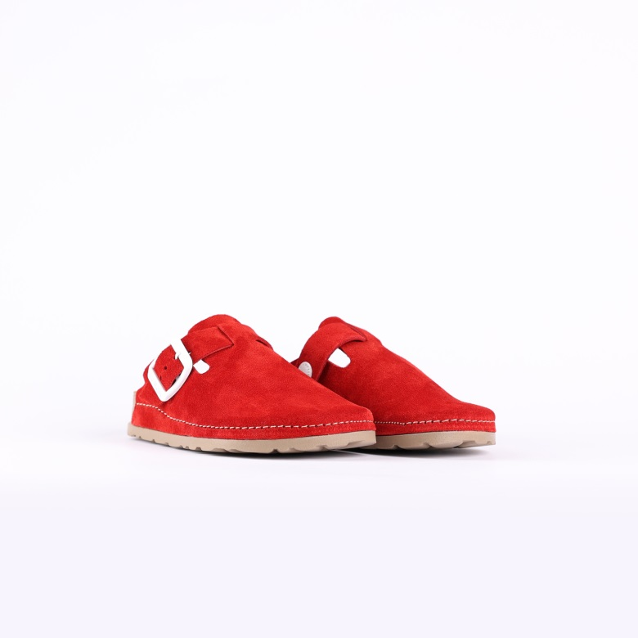

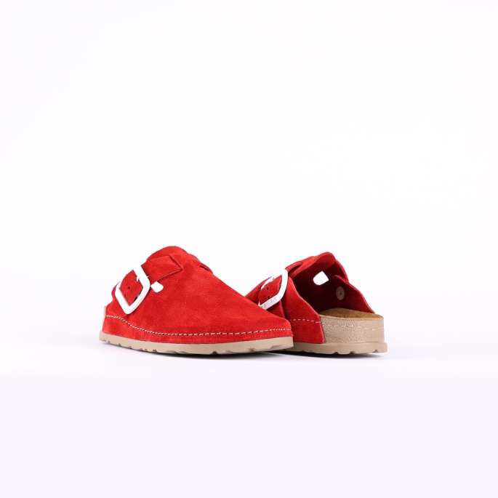

Code: N255-1V081RED0
Upper : Velour
Lining : Leather Sole : PU (Polyurethane) Accessories : Yes Heel Type : Anatomic

SIZE: 25-35

SLIPPERS – NEXA- DARK ROSE

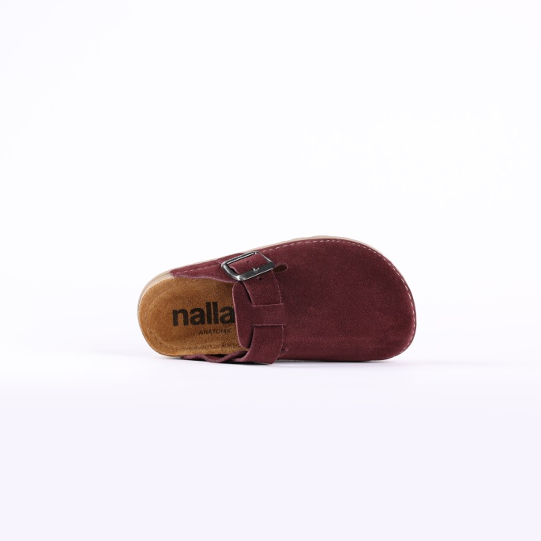
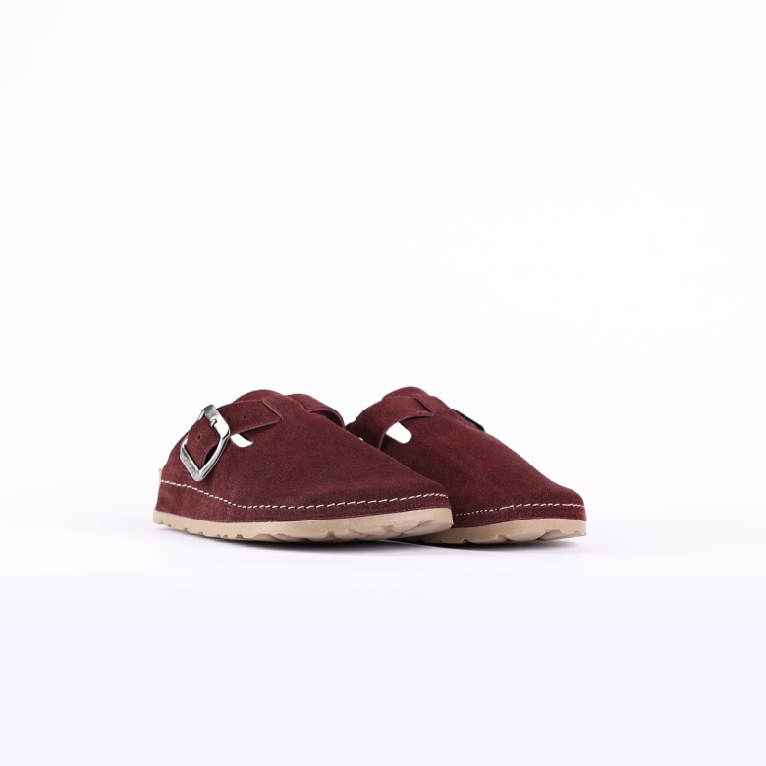

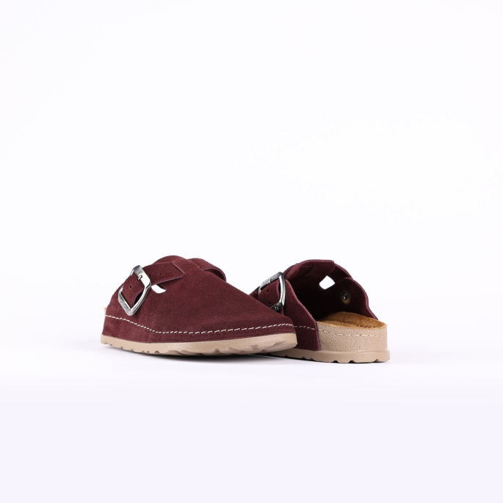

Code: N255-1V081DROS
Upper : Velour
Lining : Leather Sole : PU (Polyurethane) Accessories : Yes Heel Type : Anatomic

SIZE: 25-35

SLIPPERS – NEXA-STONE

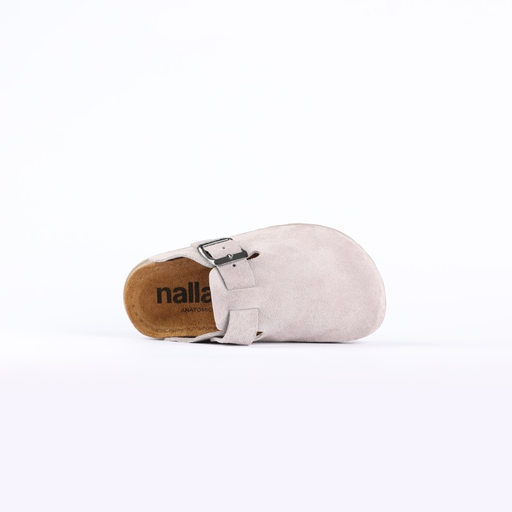
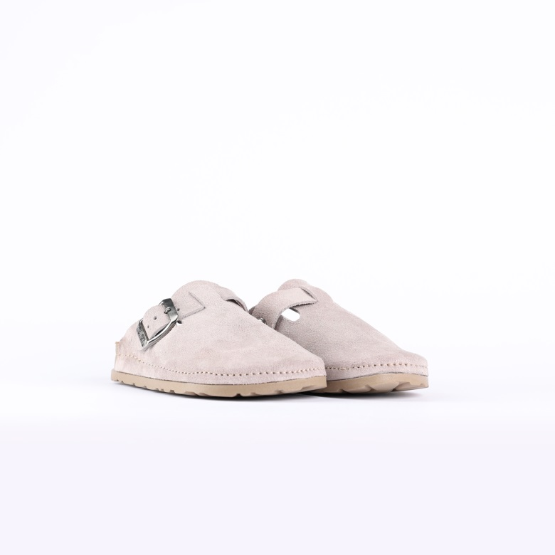
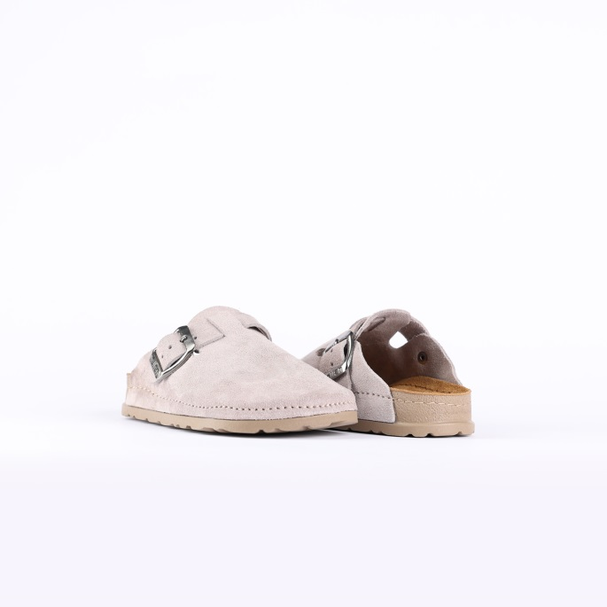

- Code: N255-1V081STON
Upper : Velour
Lining : Leather Sole : PU (Polyurethane) Accessories : Yes Heel Type : Anatomic

SIZE: 25-35

SLIPPERS – NEXA- ROSE BISQUE

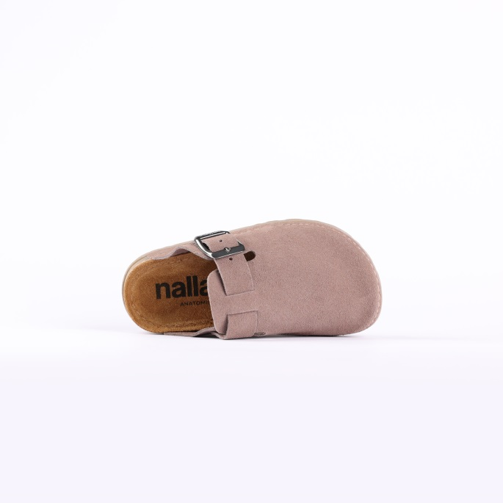
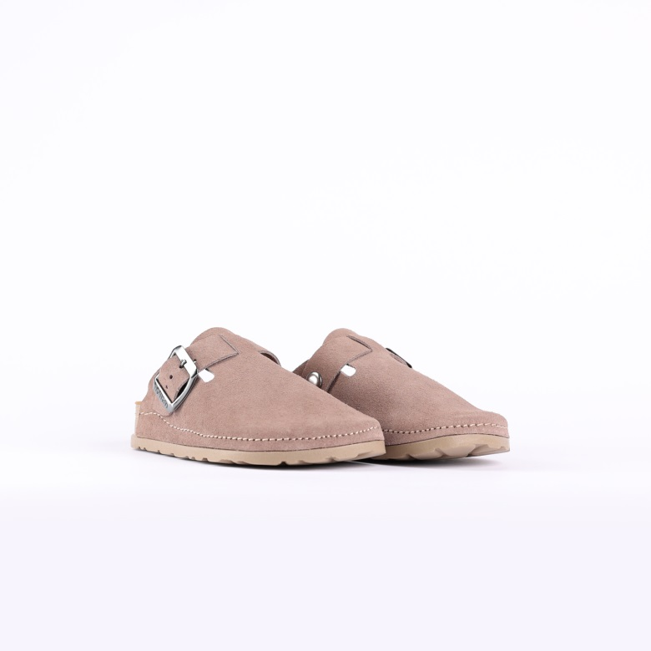

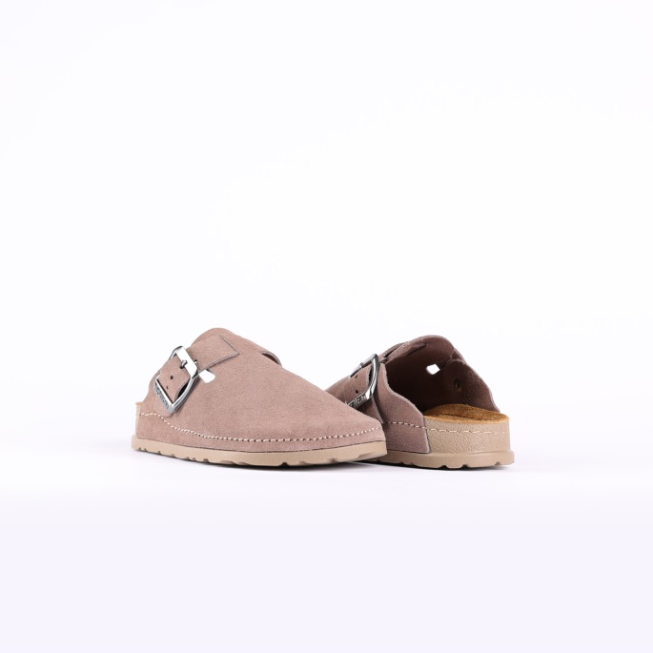

- Code: N255-1V081RBIS
Upper : Velour
Lining : Leather Sole : PU (Polyurethane) Accessories : Yes Heel Type : Anatomic

SIZE: 25-35

SLIPPERS – NEXA- YALE

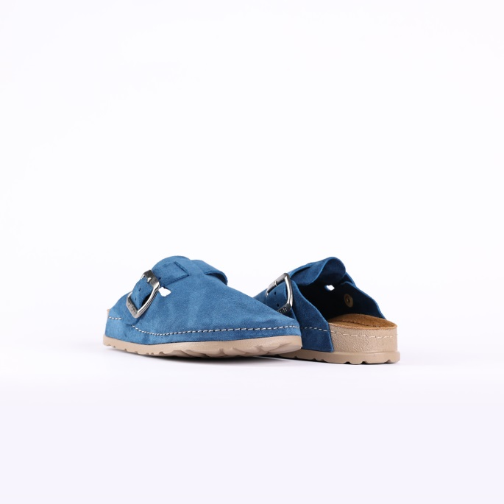
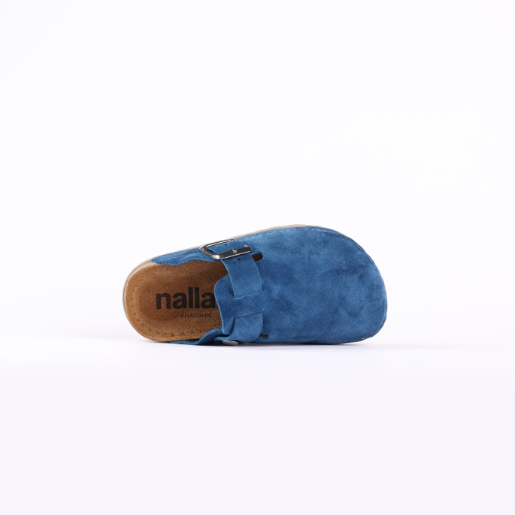
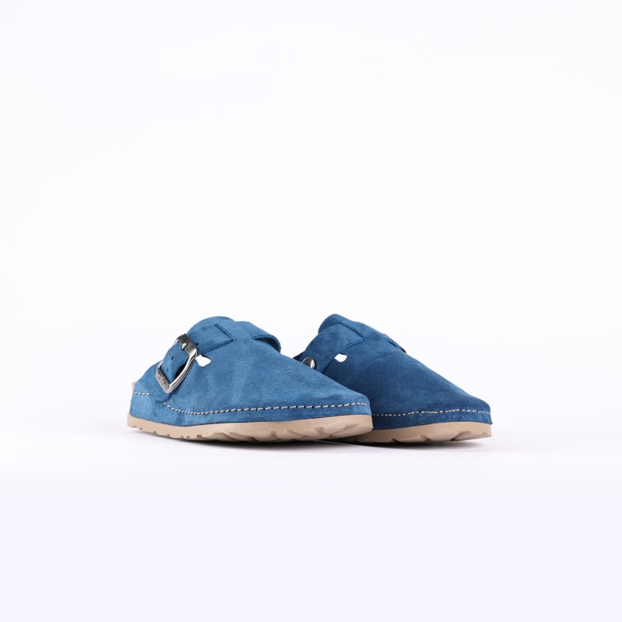

- Code: N255-1V081YALE
Upper : Velour
Lining : Leather Sole : PU (Polyurethane) Accessories : Yes Heel Type : Anatomic

SIZE: 25-35

SLIPPERS – NEXA- LILAC

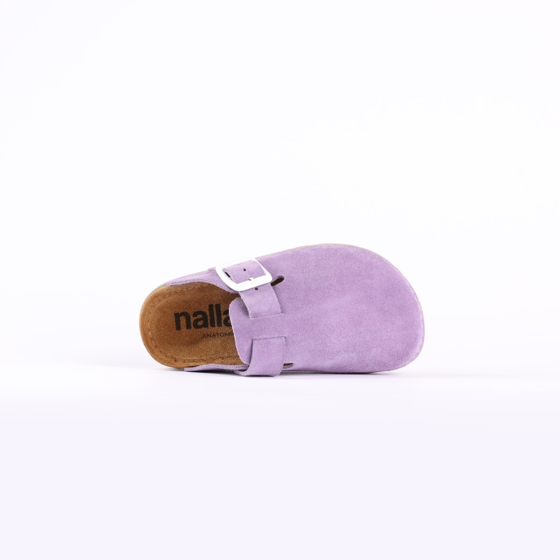
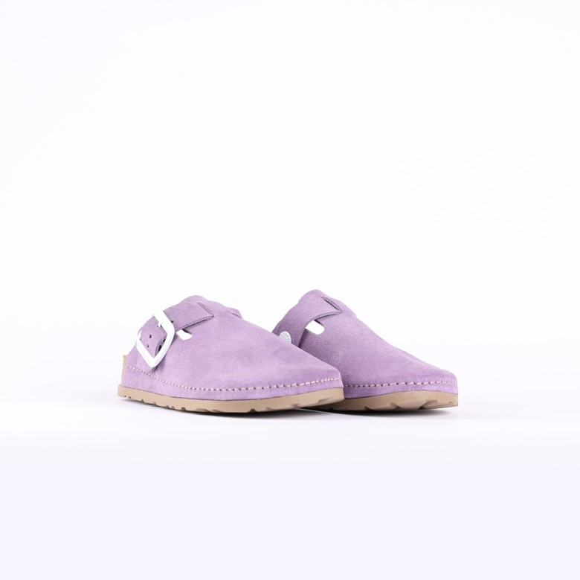

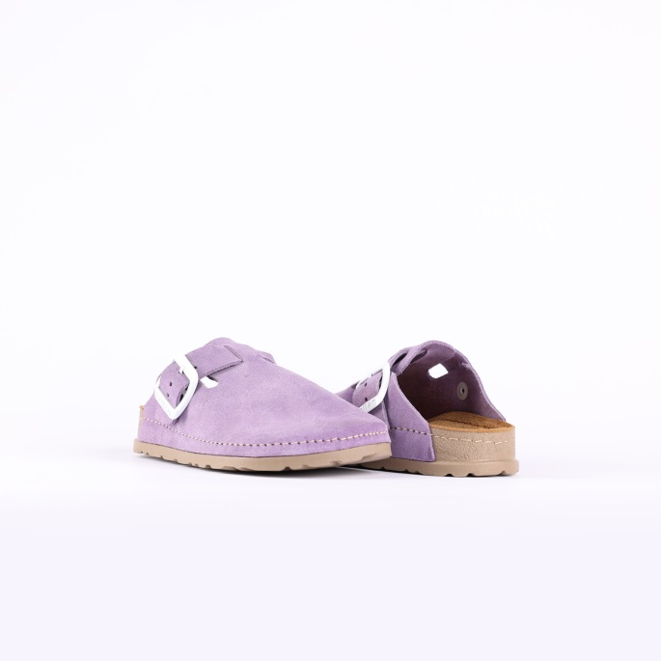

- Code: N255-1V081LILA
Upper : Velour
Lining : Leather Sole : PU (Polyurethane) Accessories : Yes Heel Type : Anatomic

F-Size : 35-41
M-Size: 41-46

Upper - Leather
Lining -Leather
Midsole - PU(polyurethane)
Sole - PU(polyurethane)
Accessories - Buckle
Heel Type - Flat Anatomic
ZOE-GOLD

Upper - Leather
Lining -Leather
Midsole - PU(polyurethane)
Sole - PU(polyurethane)
Accessories - Buckle
Heel Type - Flat Anatomic

Upper - Leather
Lining -Leather
Midsole - PU(polyurethane)
Sole - PU(polyurethane)
Accessories - Buckle
Heel Type - Flat Anatomic

Upper - Leather
Lining -Leather
Midsole - PU(polyurethane)
Sole - PU(polyurethane)
Accessories - Buckle
Heel Type - Flat Anatomic

Upper - Leather
Lining -Leather
Midsole - PU(polyurethane)
Sole - PU(polyurethane)
Accessories - Buckle
Heel Type - Flat Anatomic

Upper - Leather
Lining -Leather
Midsole - PU(polyurethane)
Sole - PU(polyurethane)
Accessories - Buckle
Heel Type - Flat Anatomic

Upper - Leather
Lining -Leather
Midsole - PU(polyurethane)
Sole - PU(polyurethane)
Accessories - Buckle
Heel Type - Flat Anatomic

Upper - Leather
Lining -Leather
Midsole - PU(polyurethane)
Sole - PU(polyurethane)
Accessories - Buckle
Heel Type - Flat Anatomic

Upper - Leather
Lining -Leather
Midsole - PU(polyurethane)
Sole - PU(polyurethane)
Accessories - Buckle
Heel Type - Flat Anatomic

Upper - Leather
Lining -Leather
Midsole - PU(polyurethane)
Sole - PU(polyurethane)
Accessories - Buckle
Heel Type - Flat Anatomic

Upper - Leather
Lining -Leather
Midsole - PU(polyurethane)
Sole - PU(polyurethane)
Accessories - Buckle
Heel Type - Flat Anatomic

Upper - Leather
Lining -Leather
Midsole - PU(polyurethane)
Sole - PU(polyurethane)
Accessories - Buckle
Heel Type - Flat Anatomic
Men- WHITE
- Code: N402-2L005WHIT
Upper : Leather Lining : Leather Sole : PU (Polyurethane)
Accessories : Buckle Heel Type : ANATOMIC

SIZE: 25-35

